

SCHOOL OF COMPUTING

Department of COMPUTER SCIENCE AND ENGINEERING
DATA ANALYSIS ESSENTIALS
CERTIFICATE

This is to certify that the Cornerstone project work entitled “WATER QUALITY DATA ANALYSIS SYSTEM” is submitted by
K. PADMASRI KRUPA | (25B11CS396)
N. SAVITHA | (25B11CS650)
P. LAHARI | (25B11CS689)
K. SIVANI | (25B11CS467)

in partial fulfilment of the requirements for the award of the B.Tech. degree in Computer Science and Engineering for the academic year 2026-2027

Project Guide Head of the Department
K. Vydehi Dr. A Phani Sridhar
Assistant Professor, Assistant Professor,
Department of CSE Department of CSE

DECLARATION

We hereby declare that the project entitled “WATER QUALITY DATA ANALYSIS SYSTEM” is our original work and is submitted to ADITYA UNIVERSITY, Surampalem, in partial fulfillment of the requirements for the award of the B.Tech. degree in Computer Science and Engineering
We further declare that this project work has not been submitted, either in full or in part, for the award of any degree or diploma in this or any other institution. We also confirm that this work has been carried out with academic honesty and complies with the Institutional Academic Integrity and AI Usage Policy.
Place:
Surampalem
Date:
By
K. PADMASRI KRUPA | (25B11CS396)
N. SAVITHA | (25B11CS650)
P. LAHARI | (25B11CS689)
K. SIVANI | (25B11CS467)
03-04-2026

ACKNOWLEDGEMENT

It is with immense pleasure that we express our sincere gratitude to our Cornerstone Project Guide, K. Vydehi, Assistant Professor, who has guided us throughout the project. Her valuable support, encouragement, and guidance have greatly contributed to the successful completion of this work.
We would like to thank our Deputy Heads of the Department, Dr. K. Chandra Sekhar, Associate Professor, Dr. Hari Jyothula, Associate Professor, Dr. P. Siva Satya Prasad, Assistant Professor, Department of CSE for their support and valuable suggestions.
Our deepest thanks to our Head of the Department Dr. A Phani Sridhar
for his inspiration and for providing all the necessary facilities and resources required for this project.
We also extend our sincere thanks to Dr. M.V. Rajesh, Associate Dean, School of Engineering for their encouragement and support during the course of our project.
We would like to express our sincere gratitude to Dr. G. Suresh, Registrar,
Dr. A Ramesh, Pro Vice-Chancellor (Engineering & Sciences), Dr. S. Rama Sree,
Pro Vice-Chancellor (Academics), Dr. M.B. Srinivas, Vice-Chancellor, Dr. M. Sreenivasa Reddy, Deputy Pro Chancellor and Management, Aditya University for providing excellent infrastructure and state-of-the-art laboratories.
Finally, we would like to thank the faculty members, lab technicians, non-teaching staff,
and our friends who have directly or indirectly supported us in completing this Cornerstone project successfully.

ABSTRACT
Water quality is essential for human health, aquatic ecosystems, and environmental sustainability. It is influenced by several physical and chemical parameters such as pH, turbidity, dissolved oxygen (DO), Total Dissolved Solids (TDS), and other water-quality indicators. Analyzing these parameters systematically is necessary to understand variations in water quality across different sampling locations.
The Water Quality Data Analysis System is a data-analysis project developed using Python to analyze real-world water-quality observations. The dataset used in this project contains 103 observations and 21 attributes collected from 12 sampling locations. The dataset was obtained from PANGAEA – Data Publisher for Earth & Environmental Science and contains observations from the Yucatán Peninsula, Mexico.
The project begins with dataset collection and loading into Google Colab using Pandas. Data preprocessing includes identifying and handling missing values, checking duplicate records, examining data types, and detecting potential outliers using Box Plot and Interquartile Range (IQR) methods. A total of 52 missing entries were identified across seven attributes and were handled using median imputation. No duplicate records were found. Potential outliers were identified in pH, Turbidity, and TDS and were retained after examination because they may represent genuine variations in water-quality observations.
Exploratory Data Analysis was performed on important parameters such as pH, dissolved oxygen, TDS, turbidity, and WQI. Descriptive statistics, histograms, box plots, bar charts, scatter plots, and correlation analysis were used to understand the distribution, variation, and relationships among the parameters. Location-wise analysis was performed by calculating average WQI for the sampling sites, while water-quality classification was analyzed to understand the distribution of different water-quality categories.
The project provides a systematic approach for cleaning, analyzing, visualizing, and interpreting water-quality data. The current implementation focuses on descriptive and exploratory analysis, while machine-learning-based water-quality prediction and interactive monitoring dashboards are considered future enhancements.

TABLE OF CONTENTS

S.No. | Contents | Pages
1 | Title Page | i
2 | Certificate | ii
3 | Declaration | iii
4 | Acknowledgement | iv
5 | Abstract | v
6 | Table of Contents | vi
7 | List of Figures | vii
8 | List of Tables | viii
Chapter 1 | Introduction
1.1 | Introduction to the Project
1.2 | Problem Statement
1.3 | Objectives of the Project
1.4 | Scope of the Project
Chapter 2 | Dataset Description and Understanding
2.1 | Dataset Source
2.2 | Dataset Description
2.3 | Features / Attributes
2.4 | Target Variable, if applicable
2.5 | Dataset Statistics / Initial Exploration
Chapter 3 | Data Preprocessing
3.1 | Data Collection / Loading
3.2 | Handling Missing Values
3.3 | Handling Duplicate / Inconsistent Data
3.4 | Feature Scaling
3.5 | Standardization
3.6 | Label Encoding
3.7 | One-Hot Encoding
3.8 | Other Project-Specific Preprocessing
Chapter 4 | System Design and Methodology
4.1 | Proposed Methodology
4.2 | System Workflow / Architecture
4.3 | Flowchart
4.4 | Tools and Technologies Used
4.5 | Algorithm / Model Used
Chapter 5 | Implementation
5.1 | Development Environment
5.2 | Dataset Loading and Exploration
5.3 | Preprocessing Implementation
5.4 | Exploratory Data Analysis (EDA)
5.5 | Model / Analysis Implementation
5.6 | Important Code Explanation
Chapter 6 | Data Visualization and Results
6.1 | Bar Graph
6.2 | Pie Chart
6.3 | Histogram
6.4 | Box Plot
6.5 | Line Chart
6.6 | Scatter Plot
6.7 | Project-Specific Visualizations
6.8 | Interpretation of Visualizations
Chapter 7 | Model Evaluation / Analysis of Results
7.1 | Evaluation Metrics
7.2 | Experimental Results
7.3 | Result Interpretation
7.4 | Discussion
Chapter 8 | Output Screenshots
8.1 | Input / Dataset Screenshots
8.2 | Preprocessing Outputs
8.3 | Visualization Outputs
8.4 | Prediction / Analysis Outputs
Chapter 9 | Conclusion and Future Enhancements
9.1 | Conclusion
9.2 | Limitations
9.3 | Future Enhancements
10 | References
11 | Appendix – Source Code

LIST OF FIGURES
Figure No. | Figure Name | Page No.
Figure 4.1 | System Workflow | 24
Figure 4.2 | Flowchart | 25
Figure 5.1 | Implementation Workflow | 38
Figure 6.1 | Average WQI by Sampling Site | 40
Figure 6.2 | Water Quality Classification | 41
Figure 6.3 | Distribution of pH | 42
Figure 6.4 | Distribution of Dissolved Oxygen (DO) | 42
Figure 6.5 | Distribution of TDS | 43
Figure 6.6 | Distribution of Turbidity | 44
Figure 6.7 | Distribution of Water Quality Index (WQI) | 45
Figure 6.8 | Box Plot of pH | 45
Figure 6.9 | Box Plot of Turbidity | 46
Figure 6.10 | Box Plot of Dissolved Oxygen (DO) | 47
Figure 6.11 | Box Plot of TDS | 47
Figure 6.12 | Box Plot of Water Quality Index (WQI) | 48
Figure 6.13 | pH vs WQI | 49
Figure 6.14 | DO vs WQI | 50
Figure 6.15 | TDS vs WQI | 50
Figure 6.16 | Turbidity vs WQI | 51
Figure 6.17 | TDS vs pH | 52
Figure 6.18 | Correlation Heatmap of Water Quality Parameters | 53
Figure 8.1 | Dataset Loaded in Google Colab | 61
Figure 8.2 | First Few Records of the Dataset | 61
Figure 8.3 | Dataset Shape and Structure | 62
Figure 8.4 | Missing Value Analysis | 63
Figure 8.5 | Missing Values After Imputation | 64
Figure 8.6 | Duplicate Record Check | 64
Figure 8.7 | Data Types Verification | 65
Figure 8.8 | Outlier Detection Output | 65
Figure 8.9 | Average WQI by Sampling Site | 66
Figure 8.10 | Distribution of pH Values | 67
Figure 8.11 | Box Plot for Water-Quality Parameters | 68
Figure 8.12 | TDS vs pH Scatter Plot | 68
Figure 8.13 | Correlation Heatmap of Water-Quality Parameters | 69
Figure 8.14 | Descriptive Statistical Analysis | 70

LIST OF TABLES

Table No. | Table Title | Correct Page No.
Table 2.1 | Dataset Attributes | 14
Table 2.2 | Important Parameters | 14
Table 2.3 | Missing Values Before Imputation | 15
Table 2.4 | Important Statistical Values After Preprocessing | 15
Table 3.1 | Missing Values | 17
Table 3.2 | Outlier Detection Results | 20
Table 3.3 | Preprocessing Summary | 21
Table 4.1 | Tools and Technologies Used | 25
Table 5.1 | Development Environment Used | 28
Table 7.1 | Water Quality Classification | 57
Table 7.2 | Experimental Results / Statistical Summary | 57
Table 7.3 | WQI Statistics by Classification | 58

CHAPTER 1
INTRODUCTION
1.1 Introduction to the Project
Water is one of the most important natural resources required for human life, aquatic ecosystems, agriculture, and environmental sustainability. Maintaining good water quality is important because changes in the physical and chemical properties of water can affect living organisms and the usability of water resources.
Water quality can be studied using several parameters such as pH, turbidity, dissolved oxygen (DO), Total Dissolved Solids (TDS), temperature, conductivity, biochemical oxygen demand, total nitrogen, and total phosphorus. These parameters provide information about the physical and chemical characteristics of water.
However, raw water-quality datasets contain multiple observations collected from different locations and may contain missing values, duplicate records, and unusual observations. Directly analyzing such data can make it difficult to identify meaningful patterns and variations.
The Water Quality Data Analysis System applies data-analysis techniques to a real-world water-quality dataset. Python and its data-analysis libraries are used to load, clean, preprocess, analyze, visualize, and interpret the dataset.
The project focuses on important parameters including pH, Turbidity, Dissolved Oxygen, TDS, and Water Quality Index (WQI). Exploratory data analysis, descriptive statistics, outlier detection, location-wise analysis, water-quality classification, and graphical visualization are used to understand the available water-quality observations.

1.2 Problem Statement
Water quality can vary across different sampling locations and observation periods because of changes in physical and chemical conditions.
Important parameters such as pH, turbidity, dissolved oxygen, and Total Dissolved Solids provide useful information about water conditions. However, analyzing individual parameters separately can make it difficult to understand the overall characteristics of the dataset.
Raw water-quality datasets may also contain missing values and unusual observations that need to be examined before analysis. Therefore, a systematic data-analysis approach is required to clean the dataset, identify potential outliers, analyze important parameters, compare conditions across sampling locations, and visualize the results.
The proposed Water Quality Data Analysis System addresses this requirement by applying Python-based data preprocessing, exploratory data analysis, statistical analysis, visualization, and Water Quality Index-based analysis to the selected dataset.

1.3 Objectives of the Project
The main objectives of the Water Quality Data Analysis System are:
- To analyze water-quality data collected from different sampling locations.
- To study key water-quality parameters such as pH, turbidity, dissolved oxygen (DO), and TDS.
- To clean and preprocess the dataset by handling missing values, duplicate records, and potential outliers.
- To compare water-quality conditions across different sampling locations.
- To identify patterns, trends, and relationships among important water-quality parameters.
- To create meaningful visualizations for better understanding and interpretation of the data.
- To assess the overall water-quality condition using the available Water Quality classification and Water Quality Index (WQI).
- To provide a foundation for future water-quality prediction using machine-learning techniques.

1.4 Scope of the Project
The scope of the Water Quality Data Analysis System is to analyze and interpret the available water-quality dataset using Python-based data-analysis techniques.
The project covers:
- Collection and loading of a real-world water-quality dataset.
- Understanding the structure and attributes of the dataset.
- Identification and handling of missing values.
- Detection of duplicate records.
- Detection and examination of potential outliers.
- Checking data types and preprocessing requirements.
- Exploratory Data Analysis of major water-quality parameters.
- Descriptive statistical analysis.
- Distribution analysis using histograms.
- Location-wise Water Quality Index analysis.
- Water-quality classification analysis.
- Correlation analysis between numerical parameters.
- Visualization using bar charts, histograms, box plots, scatter plots, and a correlation heatmap.
- Interpretation of the obtained results.
The current project focuses on descriptive and exploratory data analysis. Machine-learning-based water-quality prediction and interactive monitoring are considered future enhancements.

CHAPTER 2
DATASET DESCRIPTION AND UNDERSTANDING
2.1 Dataset Source
The dataset used in this project was obtained from PANGAEA – Data Publisher for Earth & Environmental Science.
The dataset contains water-quality observations from the Yucatán Peninsula, Mexico.
The original dataset was available in .tab (tab-delimited) format. The file was converted into CSV format for easier processing using Python and Pandas.
The converted CSV dataset was stored in Google Drive and accessed through Google Colab during the implementation of the project.

2.2 Dataset Description
The selected dataset contains real-world water-quality observations collected from different sampling locations in the Yucatán Peninsula, Mexico.
The dataset consists of 103 observations and 21 attributes. The observations represent water-quality measurements collected from 12 different sampling locations.
The dataset contains both numerical and categorical attributes. Numerical attributes represent measured physical and chemical water-quality parameters, while categorical attributes provide information such as sampling site and water-quality classification.
The dataset includes important parameters such as pH, dissolved oxygen, Total Dissolved Solids, turbidity, Water Quality Index, and Water Quality classification. It also contains additional attributes such as temperature, electrical conductivity, total suspended solids, biochemical oxygen demand, total nitrogen, and total phosphorus.

2.3 Features / Attributes
Table 2.1 : Dataset Attributes
No. | Attribute
1 | Code
2 | Site
3 | Year sampl
4 | Latitude
5 | Logitude
6 | Chl a [mg/m**3]
7 | Coli bac fec [MPN/100 ml]
8 | Coli bac tot [MPN/100 ml]
9 | BOD [mg/l]
10 | TN [mg/l]
11 | TP [mg/l]
12 | TDS[mg/l]
13 | EC [µS/cm]
14 | pH
15 | DO [mg/l]
16 | TSS [mg/l]
17 | Turbidity [NTU]
18 | Temp [°C]
19 | TI
20 | WQI
21 | Water quality

Table 2.2 : Important parameters
Parameter | Description
Site | Sampling Location
pH | pH measurement of water
DO | Dissolved oxygen
TDS | Total dissolved solids
Turbidity | Turbidity measurement
WQI | Water Quality Index
Water quality | Water-quality classification

2.4 Target Variable, if applicable
The current implementation is a descriptive and exploratory data-analysis project and does not use a machine-learning prediction model. Therefore, a separate machine-learning target variable is not defined.
The WQI and Water quality attributes are used for analysis and interpretation of the water-quality condition. Water-quality categories present in the dataset are used to study the distribution of observations across different classification categories.

2.5 Dataset Statistics / Initial Exploration
Initial Dataset
- Rows: 103
- Columns: 21
- Sampling locations: 12
Table 2.3 : Missing Values Before preprocessing
Parameter | Missing
Chl a | 4
BOD | 9
pH | 15
DO | 12
TSS | 4
Turbidity | 4
TI | 4
Total | 52

Table 2.4 : Important statistical values after preprocessing

Parameter | Mean | Minimum | Maximum
pH | 7.7016 | 6.30 | 9.25
DO | 5.2628 | 2.30 | 8.80
TDS | 1034.4211 | 99.20 | 3861.32
Turbidity | 7.0251 | 2.50 | 111.85
WQI | 69.2233 | 45 | 100
CHAPTER 3
DATA PREPROCESSING
Data preprocessing is an important stage in the Water Quality Data Analysis System. The collected water-quality dataset must be prepared before performing exploratory data analysis and visualization to ensure that the analysis is reliable and meaningful.
The dataset contains observations related to different water-quality parameters such as pH, Turbidity, Dissolved Oxygen (DO), Total Dissolved Solids (TDS), and Water Quality Index (WQI). Since raw datasets may contain missing values, duplicate records, different data types, and unusual observations, preprocessing is required to identify and handle these issues.
In this project, the dataset was loaded and examined using Python and Pandas. Missing values were identified and handled using median imputation. Duplicate records were checked, and potential outliers were detected using box plots and the Interquartile Range (IQR) method. The data types of the attributes were also verified.
Feature scaling, standardization, label encoding, and one-hot encoding were not applied because the current project focuses on descriptive analysis, exploratory data analysis, statistical analysis, and visualization rather than machine-learning model development.
The preprocessing steps performed in this project help prepare a clean and consistent dataset for further analysis and interpretation of water-quality conditions.

3.1 Data Collection / Loading
The water-quality dataset used for this project was obtained from PANGAEA – Data Publisher for Earth & Environmental Science. The dataset contains water-quality observations from the Yucatán Peninsula, Mexico.
The original dataset was available in .tab (tab-delimited) format. For convenient processing and analysis, the file was converted into CSV format. The converted CSV file was stored in Google Drive and accessed through Google Colab.
The dataset was loaded into a Pandas DataFrame using the read_csv() function. After loading, the dataset was examined using head(), shape, info(), and describe() functions to understand its structure, attributes, data types, and statistical characteristics.
The dataset contains:
- 103 observations
- 21 attributes
- 12 sampling locations
The dataset contains both numerical and categorical attributes. The major water-quality parameters considered in this project include pH, Turbidity, Dissolved Oxygen (DO), TDS, and WQI.

3.2 Handling Missing Values
Missing values were checked for all attributes using Pandas. A total of 52 missing entries were identified across seven attributes.
Table 3.1 : Missing Values
The missing values were present in:
Attribute | Missing Values
Chl a [mg/m³] | 4
BOD [mg/l] | 9
pH | 15
DO [mg/l] | 12
TSS [mg/l] | 4
Turbidity [NTU] | 4
TI | 4
Total | 52
Since these are numerical water-quality parameters, median imputation was used to handle the missing values.
The median of each respective attribute was calculated, and the missing observations were replaced with the corresponding median value. Median imputation was selected because it is less affected by extreme values and is suitable for numerical environmental data.
After imputation, the dataset was checked again for missing values. The result showed that the missing-value count for all attributes became 0.
Therefore, the dataset was successfully prepared without removing observations because of missing values.

3.3 Handling Duplicate / Inconsistent Data
Duplicate records were checked after handling the missing values. The dataset was examined for completely duplicated rows using Pandas.
The duplicate check produced the following result:
Number of duplicate records = 0
Since no duplicate records were found, no rows were removed during this preprocessing step. The dataset retained all 103 observations and 21 attributes.
The data types of the attributes were also checked. Numerical attributes were retained in numerical form, while categorical attributes such as Site and Water quality were identified.
No additional inconsistent records requiring removal were identified during the preprocessing stage.

3.4 Feature Scaling
Feature scaling is generally used to bring numerical features into comparable ranges, particularly when different features have considerably different units or magnitudes.
In this project, feature scaling was not applied because the current implementation focuses on descriptive analysis, exploratory data analysis, statistical analysis, and visualization.
The water-quality parameters were analyzed using their original values and units so that their actual environmental measurements could be interpreted directly.
Therefore, the original numerical values were retained without applying Min-Max scaling or any other scaling technique. The Review-2 implementation explicitly states that feature scaling was not required for the current descriptive analysis.

3.5 Standardization
Standardization is a preprocessing technique used to transform numerical features so that they have a common scale, generally with a mean of 0 and a standard deviation of 1.
Standardization was not performed in this project because the current analysis does not involve a machine-learning model that requires standardized input features.
The project focuses on understanding the actual distributions and variations of water-quality parameters such as pH, Turbidity, DO, TDS, and WQI. Applying standardization would change the original measurement scale and make direct interpretation of these parameters less straightforward.
Therefore, the original values were retained for further analysis.

3.6 Label Encoding
Label encoding is used to convert categorical values into numerical labels. It is generally required when categorical variables are used as input features for certain machine-learning algorithms.
In the present project, attributes such as Site and Water quality are categorical. However, they were not used as machine-learning input features.
Instead, the categorical information was used directly for grouping, location-wise analysis, and water-quality classification analysis.
Therefore, label encoding was not required for the current implementation.

3.7 One-Hot Encoding
One-hot encoding converts categorical values into separate binary columns. It is commonly used when categorical variables need to be provided as numerical input to machine-learning models.
In this project, no machine-learning model was implemented during the current analysis. The categorical attributes were used for descriptive and classification-based analysis rather than as model input.
Therefore, one-hot encoding was not applied to the dataset.
The attributes were retained in their original form to support location-wise and water-quality category analysis.

3.8 Other Project-Specific Preprocessing
3.8.1 Outlier Detection and Handling
Outlier detection was an important project-specific preprocessing step because water-quality measurements can contain unusual values that may represent genuine environmental variations.
Potential outliers were identified using Box Plot and Interquartile Range (IQR) methods.
For each selected parameter, the first quartile (Q1), third quartile (Q3), and IQR were calculated.
The IQR is calculated as:
IQR = Q3 − Q1
The lower and upper bounds were calculated as:
Lower Bound = Q1 − 1.5 × IQR
Upper Bound = Q3 + 1.5 × IQR
Values outside these limits were identified as potential outliers.
The analysis was performed for:
- pH
- Turbidity
- DO
- TDS
- WQI
Table 3.2 : Outlier Detection Results
The detected outliers were:
Parameter | Number of Outliers
pH | 4
Turbidity | 18
DO | 0
TDS | 1
WQI | 0
Potential unusual values included pH values such as 9.25, 8.933, 9.0, and 6.3, and a TDS value of 3861.32 mg/l.
The detected values were examined and retained, because they may represent genuine water-quality variations rather than incorrect observations. Therefore, no observations were removed based only on the outlier detection results.
3.8.2 Data Type Verification
The data types of all attributes were checked before proceeding to further analysis.
Numerical attributes were retained in numerical form, while categorical attributes such as Site and Water quality were identified appropriately.
This ensured that the attributes could be used correctly during statistical analysis, grouping, visualization, and classification analysis.
3.8.3 Preprocessing Summary
Table 3.3 : Preprocessing Summary
The preprocessing stage can be summarized as follows:
Preprocessing Step | Method / Decision | Result
Dataset Loading | Pandas read_csv() | Dataset loaded successfully
Missing Values | Median Imputation | 52 missing entries handled
Duplicate Records | Duplicate check | 0 duplicates
Outlier Detection | Box Plot + IQR | Potential outliers identified
Outlier Treatment | Examination and retention | No values removed
Data Type Checking | Pandas | Data types verified
Feature Scaling | Not applied | Not required
Standardization | Not applied | Not required
Label Encoding | Not applied | Not required
One-Hot Encoding | Not applied | Not required
After completing these preprocessing steps, the dataset was ready for the next stage of the project, which includes Exploratory Data Analysis (EDA), statistical analysis, visualization, location-wise WQI analysis, and water-quality classification.

CHAPTER 4
SYSTEM DESIGN AND METHODOLOGY
4.1 Proposed Methodology
The proposed methodology for the Water Quality Data Analysis System consists of a series of steps used to collect, preprocess, analyze, and visualize water-quality data. The main purpose of the methodology is to transform raw water-quality observations into meaningful information about the condition and variation of water.
The methodology begins with collecting a real-world water-quality dataset from PANGAEA – Data Publisher for Earth & Environmental Science. The dataset contains water-quality observations from the Yucatán Peninsula, Mexico, with 103 observations and 21 attributes. The dataset includes important parameters such as pH, Turbidity, Dissolved Oxygen (DO), Total Dissolved Solids (TDS), WQI, and Water Quality classification.
The collected dataset is then loaded into the Google Colab environment using Python and Pandas. The dataset is examined to understand its structure, attributes, data types, and statistical characteristics.
The next stage is data preprocessing. Missing values are identified and handled using median imputation. Duplicate records are checked, and potential outliers are identified using box plots and the Interquartile Range (IQR) method.
After preprocessing, Exploratory Data Analysis (EDA) is performed to understand the distribution and variation of important water-quality parameters. Statistical analysis is also carried out to obtain numerical summaries.
The analysis includes:
- Statistical analysis of important parameters.
- Water-quality analysis by sampling location.
- Water Quality classification analysis.
- pH distribution analysis.
- Relationship analysis between important parameters.
- Correlation analysis.
- Data visualization using different types of graphs.
Finally, the results are interpreted to understand variations and patterns in water quality. The overall methodology provides a systematic approach for analyzing the available water-quality observations.
Methodology Steps
Dataset Collection → Data Loading → Initial Exploration → Data Preprocessing → Exploratory Data Analysis → Statistical Analysis → Visualization → Water Quality Analysis → Result Interpretation

4.2 System Workflow / Architecture
The system workflow represents the sequence of activities performed in the Water Quality Data Analysis System. The system starts with the collection of the water-quality dataset and ends with the interpretation of the analyzed results.
System Workflow
1.Dataset Collection
The water-quality dataset is obtained from PANGAEA and prepared in CSV format.
2.Dataset Loading
The CSV dataset is loaded into Google Colab using Python and Pandas.
3.Initial Dataset Understanding
The structure, dimensions, attributes, data types, and statistical information of the dataset are examined.
4.Data Preprocessing
Missing values are identified and handled using median imputation. Duplicate records are checked, and potential outliers are detected.
5.Exploratory Data Analysis
The distribution of important water-quality parameters such as pH, DO, TDS, Turbidity, and WQI is studied.
6.Statistical Analysis
Statistical measures such as mean, minimum, maximum, and other descriptive statistics are calculated.
7.Location-wise Analysis
Average WQI values are compared across the 12 sampling locations to understand variations between locations. The project PPT specifically describes this location-wise WQI comparison.
8.Water Quality Classification
The available Water Quality categories are analyzed to understand the overall classification of the samples.
9.Visualization
Graphs such as bar charts, histograms, box plots, correlation heatmaps, and scatter plots are used to represent the results.
10.Result Interpretation
The generated results and visualizations are interpreted to identify important patterns and variations in water quality.
System Architecture
Figure 4.1: System Workflow
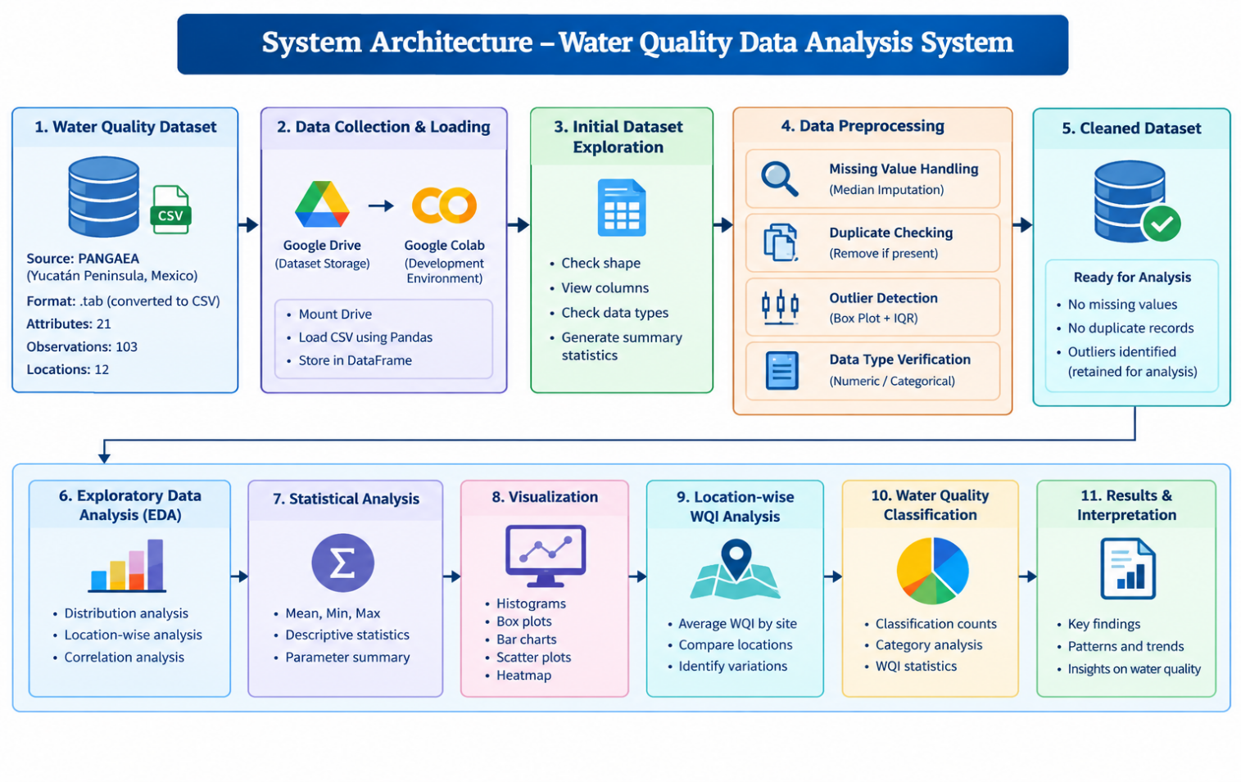
4.3 Flowchart
The flowchart of the proposed system describes the complete process followed during the project.
Flowchart Steps

Figure 4.2 : Flowchart
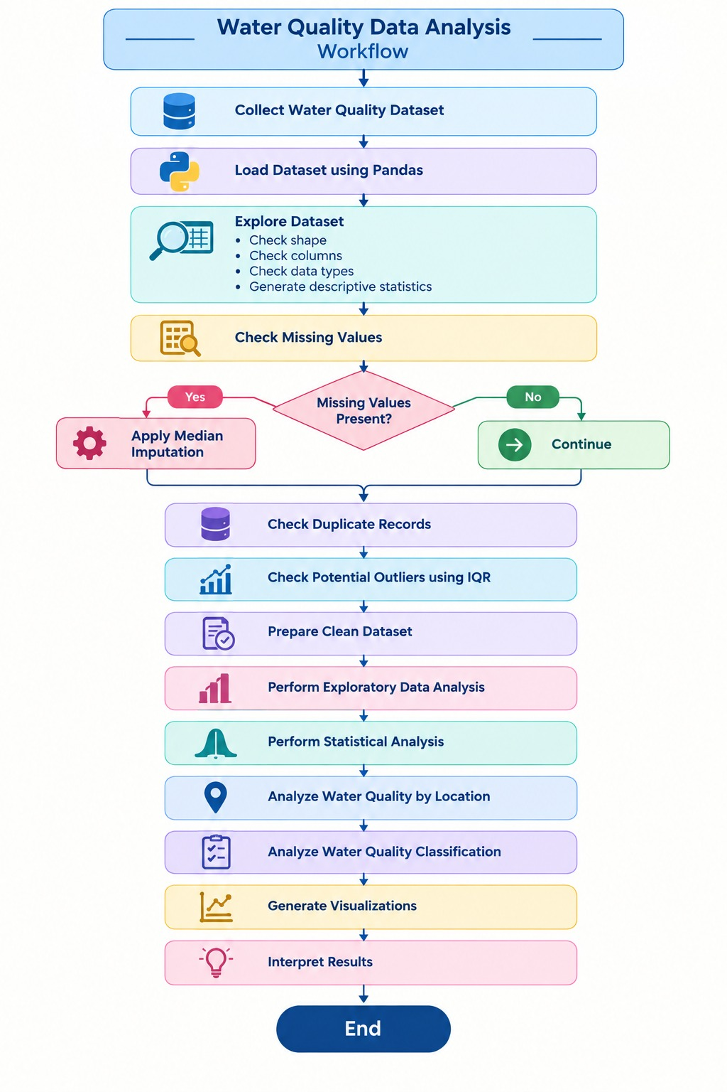
4.4 Tools and Technologies Used
The Water Quality Data Analysis System was implemented using Python-based data-analysis tools and a cloud-based development environment.
Table 4.1 : Tools and Technologies Used
Tool / Technology | Purpose
Python | Main programming language used for data analysis
Google Colab | Cloud-based environment used to execute the Python code
Pandas | Dataset loading, cleaning, manipulation, and analysis
NumPy | Numerical operations and data processing
Matplotlib | Creating graphs and visualizations
Seaborn | Creating statistical visualizations and correlation heatmaps
Google Drive | Storing and accessing the project dataset
CSV | Dataset storage format used for analysis

Python
Python is used as the primary programming language because it provides libraries that simplify data cleaning, statistical analysis, and visualization.
Pandas
Pandas is used to load the CSV dataset, examine its structure, handle missing values, check duplicates, and perform data manipulation.
NumPy
NumPy supports numerical operations required during data analysis.
Matplotlib
Matplotlib is used to generate visualizations such as histograms, bar charts, box plots, and scatter plots.
Seaborn
Seaborn is used for statistical visualizations, including correlation heatmaps and other graphical representations.
Google Colab
Google Colab provides the environment in which the Python implementation and analysis are executed.

4.5 Algorithm / Model Used
Since the current project focuses on data analysis, exploratory analysis, statistical analysis, and visualization, a machine-learning prediction model is not implemented.
The main analytical techniques used in the project are:
1.Descriptive Statistical Analysis
Descriptive statistics are used to summarize the numerical water-quality parameters. Measures such as mean, minimum, maximum, and count are used to understand the dataset.
2.Median Imputation
Missing values are handled using the median value of the respective attribute. This method is applied to the identified numerical attributes during preprocessing.
3.IQR-Based Outlier Detection
The Interquartile Range (IQR) method is used to identify potential outliers.
The formula is:
IQR = Q3 − Q1
where:
- Q1 = First Quartile
- Q3 = Third Quartile
The lower and upper limits are calculated as:
Lower Bound = Q1 − 1.5 × IQR
Upper Bound = Q3 + 1.5 × IQR
Values outside these limits are considered potential outliers.
In this project, potential outliers were detected in parameters such as pH, Turbidity, and TDS. They were examined as part of the analysis rather than automatically removed.
4.Correlation Analysis
Correlation analysis is used to study relationships between numerical water-quality parameters. A correlation matrix and heatmap are used to visually represent these relationships.
5.Location-wise WQI Analysis
Average WQI is calculated for different sampling locations to compare water-quality conditions across the locations. The PPT identifies this as one of the main analysis components.
6.Water Quality Classification Analysis
The available Water Quality classification is analyzed to understand the distribution of samples among different quality categories.
7.Visualization-Based Analysis
Graphs are used to understand patterns that may not be easily visible from numerical values alone. The project includes analysis of pH distribution and relationships between important water-quality parameters.

CHAPTER 5
IMPLEMENTATION
This chapter describes the practical implementation of the Water Quality Data Analysis System. The project was implemented using Python in Google Colab. The implementation includes dataset loading, initial exploration, preprocessing, exploratory data analysis, statistical analysis, location-wise water-quality analysis, classification analysis, and visualization.
The implementation was performed on the cleaned water-quality dataset containing 103 observations and 21 attributes. The major parameters considered for analysis include pH, Turbidity, Dissolved Oxygen (DO), Total Dissolved Solids (TDS), and Water Quality Index (WQI).

5.1 Development Environment
The Water Quality Data Analysis System was implemented using a Python-based development environment.
Table 5.1 : Development Environment Used

Component | Details
Programming Language | Python
Development Environment | Google Colab
Data Storage | Google Drive
Dataset Format | CSV
Data Manipulation | Pandas
Numerical Operations | NumPy
Visualization | Matplotlib
Statistical Visualization | Seaborn
Google Colab was used to execute the Python programs and perform the complete data-analysis process. The dataset was stored in Google Drive and accessed from the Colab environment.
Python libraries were used according to their specific purposes:
- Pandas – loading, cleaning, and manipulating the dataset.
- NumPy – numerical operations.
- Matplotlib – creating graphs and plots.
- Seaborn – statistical visualization and correlation heatmap.
The implementation does not use a machine-learning prediction model. The current implementation focuses on data preprocessing, exploratory data analysis, statistical analysis, and visualization.

5.2 Dataset Loading and Exploration
The dataset was first stored in Google Drive and accessed through Google Colab. Google Drive was mounted in the Colab environment, and the CSV file was loaded using Pandas.
Dataset Loading
The CSV file was loaded into a Pandas DataFrame. After loading, basic functions were used to understand the structure of the dataset.
The following operations were performed:
- Displaying the first few records using head().
- Checking the number of rows and columns using shape.
- Checking column names and data types using info().
- Generating descriptive statistics using describe().
- Checking missing values.
- Checking duplicate records.
Initial Dataset Information
The dataset contains:
- 103 observations
- 21 attributes
- 12 sampling locations
- Numerical and categorical attributes
- Water Quality Index (WQI)
- Water Quality classification
The dataset contains important parameters such as pH, Turbidity, DO, TDS, and WQI, which form the major focus of the analysis.
Basic Exploration Code
import pandas as pd
data = pd.read_csv("Conagua_2012-202(3).csv")
print(data.head())
print(data.shape)
print(data.info())
print(data.describe())
The initial exploration helps in understanding the dataset before applying preprocessing operations.
5.3 Preprocessing Implementation

Data preprocessing was performed to prepare the dataset for further analysis. The major preprocessing operations were missing-value handling, duplicate checking, outlier detection, and data-type verification.
5.3.1 Missing Value Handling
The dataset initially contained 52 missing values distributed across seven attributes.
The missing values were handled using median imputation. Median imputation was selected for the numerical attributes because it provides a representative value while reducing the influence of extreme observations.
The following attributes were processed:
- Chl a [mg/m³]
- BOD [mg/l]
- pH
- DO [mg/l]
- TSS [mg/l]
- Turbidity [NTU]
- TI
After applying median imputation, the dataset contained zero missing values. The Review-2 implementation also documents that 52 missing values were handled using median imputation.
Code
columns = [
'Chl a [mg/m**3]',
'BOD [mg/l]',
'pH',
'DO [mg/l]',
'TSS [mg/l]',
'Turbidity [NTU]',
'TI'
]

for column in columns:
data_clean[column] = data_clean[column].fillna(
data_clean[column].median()
)
5.3.2 Duplicate Record Checking
Duplicate records were checked to ensure that the same observation was not repeated in the dataset.
The duplicate-checking operation showed:
Number of duplicate records = 0
Therefore, no records were removed during duplicate handling.
Code
data_clean.duplicated().sum()
5.3.3 Outlier Detection
Potential outliers were identified using Box Plots and the Interquartile Range (IQR) method.
The following parameters were examined:
- pH
- Turbidity [NTU]
- DO [mg/l]
- TDS [mg/l]
- WQI
The implementation calculated Q1, Q3, IQR, lower bound, and upper bound for each parameter.
Code
Q1 = data_clean[column].quantile(0.25)
Q3 = data_clean[column].quantile(0.75)

IQR = Q3 - Q1

lower_bound = Q1 - 1.5 * IQR
upper_bound = Q3 + 1.5 * IQR
The detected values were examined rather than automatically removed because they may represent genuine variations in water-quality conditions.
5.3.4 Data Type Verification
The data types of all attributes were checked using Pandas.
Code
data_clean.dtypes
Numerical attributes were retained in numerical form, while categorical attributes such as Site and Water quality were identified.
Since the project focuses on descriptive analysis and visualization, encoding and feature scaling were not required.
5.4 Exploratory Data Analysis (EDA)
Exploratory Data Analysis was performed on the cleaned dataset to understand the distribution, variation, and relationships among important water-quality parameters.
The main parameters analyzed were:
- pH
- Turbidity
- Dissolved Oxygen (DO)
- Total Dissolved Solids (TDS)
- Water Quality Index (WQI)
The project uses descriptive statistics, histograms, box plots, scatter plots, and correlation analysis to explore the dataset.
Major EDA Operations
1.Distribution Analysis
Histograms were generated to understand the distribution of individual parameters.
The pH distribution was specifically analyzed using a histogram to observe the common range and variation of pH values.
2.Statistical Analysis
Descriptive statistics were calculated for the major parameters.
The measures include:
- Mean
- Standard deviation
- Minimum
- Maximum
- Quartiles
These values provide a numerical summary of the water-quality parameters.
3.Location-wise Analysis
The dataset contains observations from 12 sampling locations.
Average WQI was calculated for each sampling location and compared using a bar chart. This helps understand differences in water-quality conditions between locations.
4.Water Quality Classification
The available Water Quality classification was analyzed to understand the distribution of samples among different categories.
The number of samples in each category was calculated, and WQI was considered along with the classification.
5.Correlation Analysis
Correlation analysis was performed on numerical water-quality parameters to examine relationships between the parameters.
A correlation matrix and heatmap were used for visual representation.

5.5 Model / Analysis Implementation
As the current project does not implement a machine-learning prediction model, this section describes the analysis implementation performed on the cleaned dataset.
The following analyses were implemented:
5.5.1 Descriptive Statistical Analysis
Statistical measures were calculated for pH, Turbidity, DO, TDS, and WQI.
Code
data_clean[['pH',
'Turbidity [NTU]',
'DO [mg/l]',
'TDS [mg/l]',
'WQI']].describe()
This provides information about the central tendency and variation of the selected parameters.
5.5.2 Water Quality Analysis by Location
Average WQI was calculated for each sampling site.
Code
site_wqi = data_clean.groupby('Site')['WQI'].mean()
The resulting values were used to compare water-quality conditions across different locations.
5.5.3 Water Quality Classification
The number of observations belonging to each Water Quality category was calculated.
Code
data_clean['Water quality'].value_counts()
This provides an overview of the classification distribution in the dataset.
5.5.4 Correlation Analysis
The relationships between numerical parameters were analyzed using correlation.
Code
correlation = data_clean.select_dtypes(
include='number'
).corr()
A heatmap was then used to represent the correlation matrix visually.
5.5.5 Scatter Plot Analysis
Scatter plots were used to study the relationships between important water-quality parameters. The scatter plots help identify the pattern, variation, and possible relationship between two numerical variables in the dataset.
The following parameter relationships were analyzed:
- pH vs WQI
- Dissolved Oxygen (DO) vs WQI
- Total Dissolved Solids (TDS) vs WQI
- Turbidity vs WQI
- TDS vs pH
For each scatter plot, one parameter was represented on the X-axis and the other parameter on the Y-axis. The distribution of data points was observed to understand how the parameters vary with respect to each other.
pH vs WQI:
This scatter plot was used to examine the relationship between pH and Water Quality Index (WQI). It helps understand how variations in pH are associated with changes in the WQI values.
DO vs WQI:
The relationship between Dissolved Oxygen (DO) and WQI was analyzed using a scatter plot. It helps examine the variation of WQI with different dissolved oxygen values.
TDS vs WQI:
A scatter plot was used to study the relationship between Total Dissolved Solids (TDS) and WQI. It helps observe how changes in the amount of dissolved solids are distributed with respect to WQI.
Turbidity vs WQI:
This plot was used to examine the relationship between Turbidity and WQI. It provides a visual understanding of how turbidity values vary across different WQI values.
TDS vs pH:
A scatter plot was also used to analyze the relationship between TDS and pH. TDS represents the amount of dissolved substances present in water, while pH indicates the acidic or alkaline nature of water. The distribution of points helps observe the pattern and variation between these two parameters. This analysis was also included in the project review implementation.
Overall, scatter-plot analysis provides a visual method for examining relationships among important water-quality parameters and supports further interpretation of the dataset.

5.6 Implementation Workflow
The implementation of the Water Quality Data Analysis System was carried out using a systematic data-analysis workflow. The workflow starts with collecting and importing the water-quality dataset and continues through dataset understanding, preprocessing, exploratory data analysis, statistical analysis, visualization, and interpretation of results.
The complete implementation workflow is described below.
Step 1 – Dataset Collection
The water-quality dataset was obtained from PANGAEA – Data Publisher for Earth & Environmental Science. The dataset contains water-quality observations from the Yucatán Peninsula, Mexico. The original dataset was available in .tab format.
Step 2 – Dataset Preparation and Import
The original .tab file was converted into CSV format for easier processing. The CSV file was stored in Google Drive and accessed through Google Colab. The dataset was loaded into a Pandas DataFrame using Python.
Step 3 – Initial Dataset Understanding
After loading the dataset, its structure and contents were examined. The dataset contains 103 observations and 21 attributes, covering 12 sampling locations.
Functions such as head(), shape, info(), and describe() were used to understand the records, attributes, data types, non-null values, and statistical characteristics of the dataset.
Step 4 – Data Preprocessing
The dataset was then preprocessed to improve the reliability of further analysis. Missing values were identified and handled using median imputation. Duplicate records were checked, and potential outliers were detected using box plots and the IQR method.
A total of 52 missing entries were identified across seven attributes. No duplicate records were found. The detected potential outliers were examined and retained because they may represent genuine variations in water-quality observations.
Step 5 – Data Type Verification
The data types of all attributes were checked after preprocessing. Numerical attributes were retained in numerical form, while categorical attributes such as Site and Water quality were identified. Encoding and feature scaling were not required because the project focuses on descriptive and exploratory analysis rather than machine-learning model development.
Step 6 – Exploratory Data Analysis
Exploratory Data Analysis was performed on the cleaned dataset. The major parameters considered were:
- pH
- Turbidity
- Dissolved Oxygen (DO)
- Total Dissolved Solids (TDS)
- Water Quality Index (WQI)
Descriptive statistics and graphical techniques were used to understand the distribution and variation of these parameters.
Step 7 – Statistical Analysis
Statistical analysis was performed to obtain numerical summaries of the important water-quality parameters. Measures such as mean, standard deviation, minimum, maximum, and quartiles were examined.
This analysis helped understand the variation and distribution of the selected water-quality parameters.
Step 8 – Water Quality Analysis by Location
The water-quality conditions were compared across the different sampling locations. The average WQI was calculated for each sampling site and represented using a bar chart.
This helped compare the water-quality conditions among the different sampling locations.
Step 9 – Water Quality Classification Analysis
The available Water Quality classification was analyzed to understand the overall condition of the water samples. The number of samples belonging to different water-quality categories was examined along with their WQI values.
Step 10 – Data Visualization
Different visualization techniques were used to represent the results clearly. Histograms were used to study parameter distributions, box plots were used for outlier detection, bar charts were used for location and classification analysis, and scatter plots were used to examine relationships between numerical parameters.
Correlation analysis was also performed to understand relationships among the numerical water-quality parameters.
Step 11 – Result Interpretation
Finally, the outputs obtained from the statistical analysis and visualizations were examined to identify variations, patterns, relationships, and differences in water-quality conditions.
The overall implementation workflow can therefore be represented as:
Dataset Collection → Dataset Preparation → Dataset Import → Initial Dataset Understanding → Data Preprocessing → Data Type Verification → Exploratory Data Analysis → Statistical Analysis → Location-wise WQI Analysis → Water Quality Classification → Data Visualization → Result Interpretation
This workflow provides a systematic approach for analyzing the collected water-quality data and obtaining meaningful insights from the dataset.
Figure 5.1 : Implementation Workflow
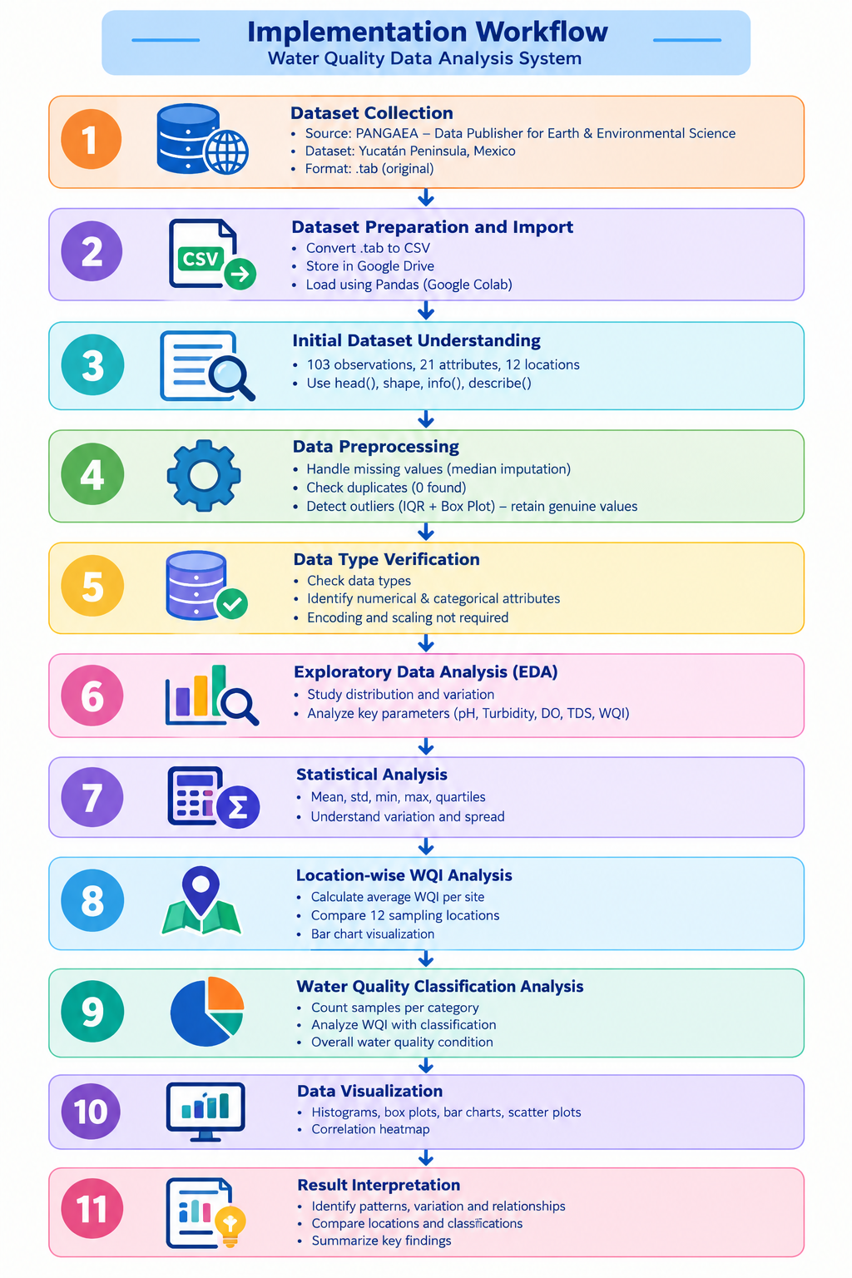

CHAPTER 6
DATA VISUALIZATION AND RESULTS
Data visualization is an important part of the Water Quality Data Analysis System because it helps represent the analyzed data in a simple and understandable form. Different visualization techniques were applied to study the distribution, variation, relationships, and water-quality conditions present in the dataset.
The visualizations were generated using Python libraries such as Matplotlib and Seaborn. The major water-quality parameters considered for visualization include pH, Turbidity, Dissolved Oxygen (DO), Total Dissolved Solids (TDS), and Water Quality Index (WQI).
The generated visualizations help in understanding the characteristics of the dataset and support the interpretation of the analysis results.
6.1 Bar Graph
Bar graphs were used in the project to compare water-quality information across sampling sites and Water Quality categories.
6.1.1 Average WQI by Sampling Site
The average WQI was calculated for each sampling site using the cleaned dataset. A bar graph was generated to compare the average WQI values across the different sampling locations.
Figure 6.1: Average WQI by Sampling Site
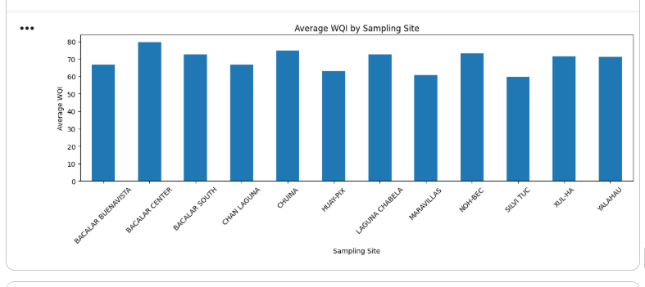

Interpretation:
The graph shows the variation in average Water Quality Index values across the sampling locations. Since the dataset contains observations from different sites, the graph helps compare the overall WQI condition between locations. Differences in bar heights indicate variation in water-quality conditions among the sampling sites.
6.1.2 Water Quality Classification
The number of observations belonging to each Water Quality category was calculated and represented using a bar graph.
The categories present in the dataset are:
- FAIR – 58 observations
- EXCELLENT – 22 observations
- GOOD – 19 observations
- POOR – 4 observations
Figure 6.2: Water Quality Classification
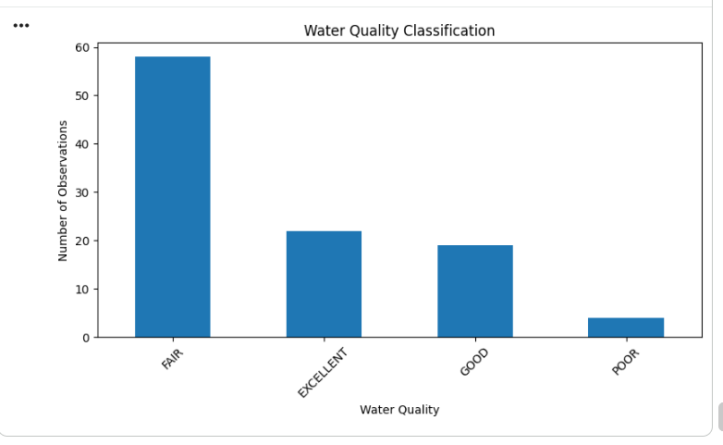

Interpretation:
The graph shows the distribution of observations among the different Water Quality categories. The FAIR category has the highest number of observations, while POOR has the lowest number of observations.

6.2 Pie Chart
A pie chart was not used in the final implementation notebook.
The Water Quality classification was represented using a bar graph, which allows direct comparison of the number of observations in each category.
Therefore, no pie-chart figure is required for this project.

6.3 Histogram
Histograms were used to study the distribution of the major numerical water-quality parameters. The final implementation generated histograms for pH, DO, TDS, Turbidity, and WQI.
6.3.1 pH Distribution
Figure 6.3: Distribution of pH
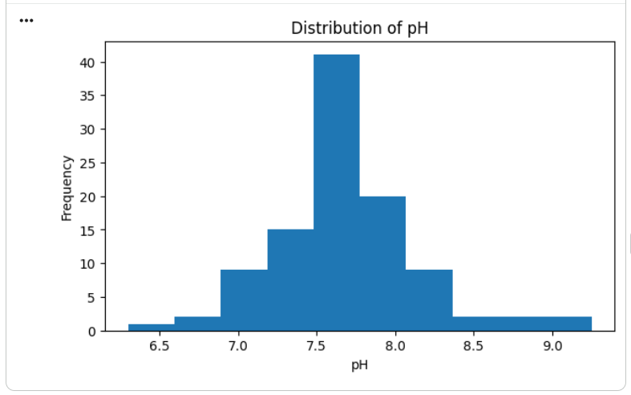

Interpretation:
The pH histogram shows how the pH observations are distributed across the dataset. It helps understand the common range and variation of pH values and also helps identify unusual observations.
6.3.2 Dissolved Oxygen Distribution
Figure 6.4: Distribution of Dissolved Oxygen (DO)
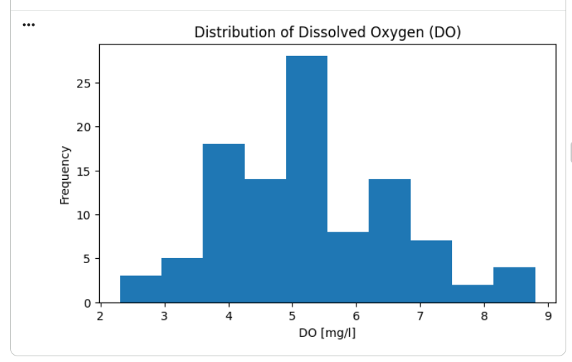
Interpretation:
The histogram represents the distribution of Dissolved Oxygen values in the dataset. It helps understand the variation in DO measurements across the observations.
6.3.3 TDS Distribution
Figure 6.5: Distribution of TDS
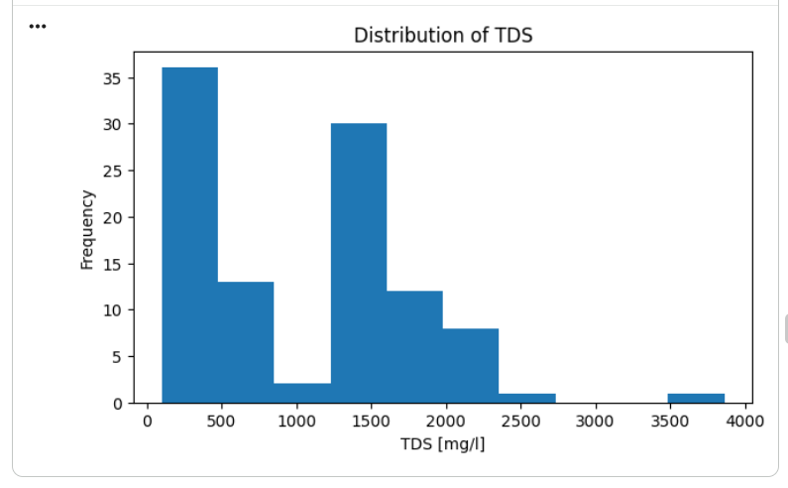
Interpretation:
The TDS histogram shows the distribution of Total Dissolved Solids values. It helps identify the range and frequency of TDS observations and shows the variation of dissolved solids in the water samples.
6.3.4 Turbidity Distribution
Figure 6.6: Distribution of Turbidity
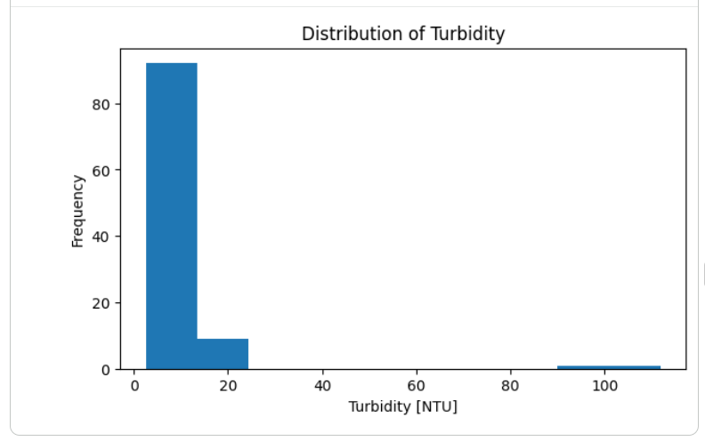
Interpretation:
The histogram represents the distribution of turbidity measurements. It helps understand the variation of turbidity values across the dataset.
6.3.5 WQI Distribution
Figure 6.7: Distribution of Water Quality Index (WQI)
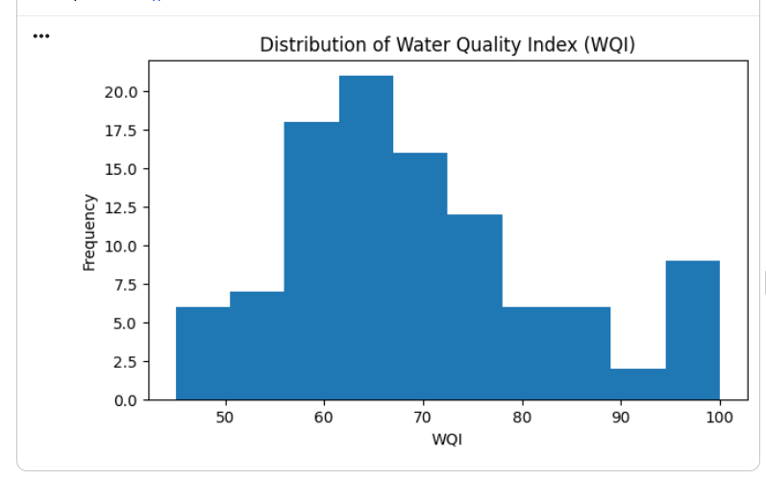
Interpretation:
The WQI histogram shows the distribution of Water Quality Index values. It helps understand how the WQI values are distributed across the observations.

6.4 Box Plot
Box plots were generated for pH, Turbidity, DO, TDS, and WQI. They were used to understand the distribution of the parameters and identify potential outliers.
6.4.1 Box Plot of pH
Figure 6.8: Box Plot of pH
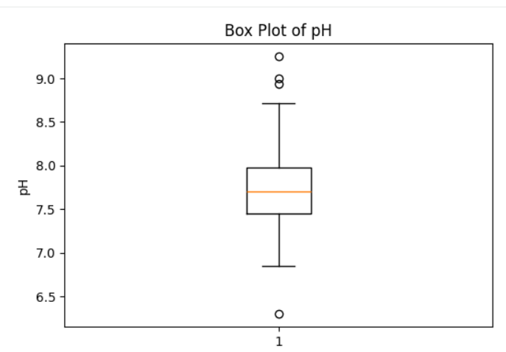
6.4.2 Box Plot of Turbidity
Figure 6.9: Box Plot of Turbidity
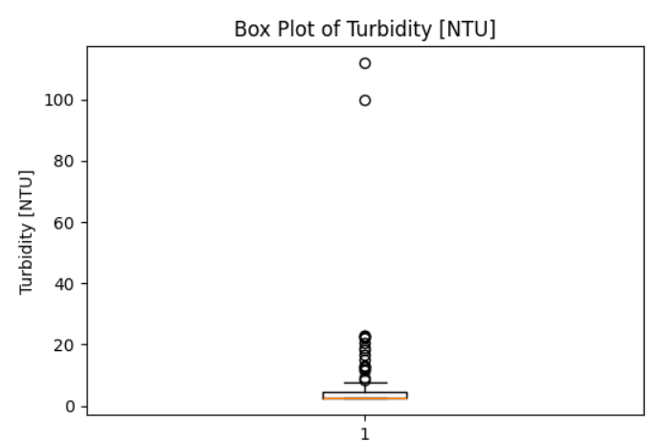
The box plot represents the spread of turbidity values and helps identify potential extreme observations.
6.4.3 Box Plot of Dissolved Oxygen
Figure 6.10: Box Plot of Dissolved Oxygen (DO)
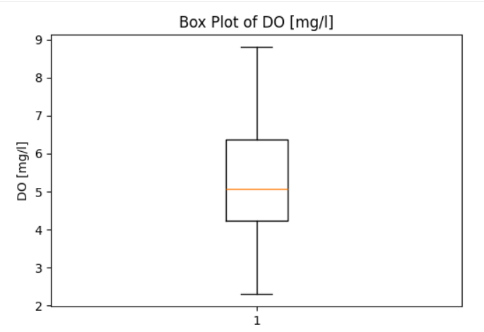
The graph shows the distribution and variation of Dissolved Oxygen values and helps identify potential outliers.
6.4.4 Box Plot of TDS
Figure 6.11: Box Plot of TDS
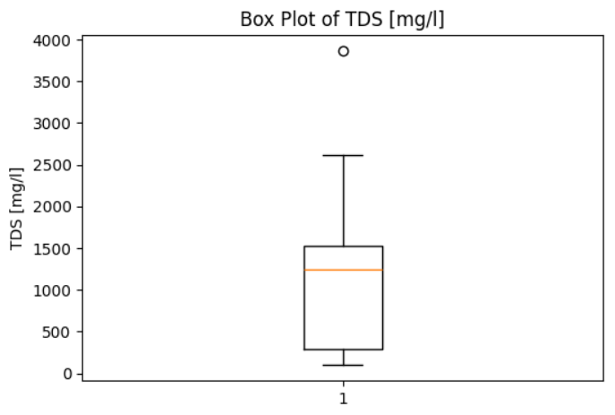
The box plot represents the distribution of TDS values and helps identify observations that are far from the main data range.
6.4.5 Box Plot of WQI
Figure 6.12: Box Plot of Water Quality Index (WQI)
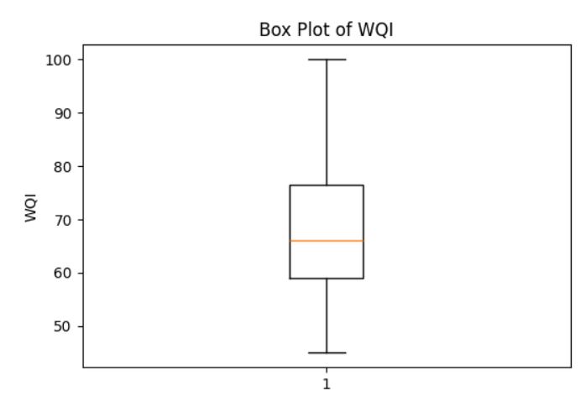
The box plot shows the distribution and spread of WQI values and helps identify potential unusual observations.
Outlier Analysis
The project used the Interquartile Range (IQR) method along with box plots for outlier detection. The implementation examined pH, Turbidity, DO, TDS, and WQI. Potential outliers were identified but were retained because they may represent genuine variations in water-quality conditions.
6.5 Line Chart
A line chart was not used in the final implementation notebook.
The project focuses on descriptive analysis, distributions, location-wise comparison, classification, correlation, and parameter relationships. Therefore, no line-chart figure is required.
6.6 Scatter Plot
Scatter plots were used to examine the relationships between important water-quality parameters and WQI.
The final implementation contains five scatter plots.
6.6.1 pH vs WQI
Figure 6.13: pH vs WQI
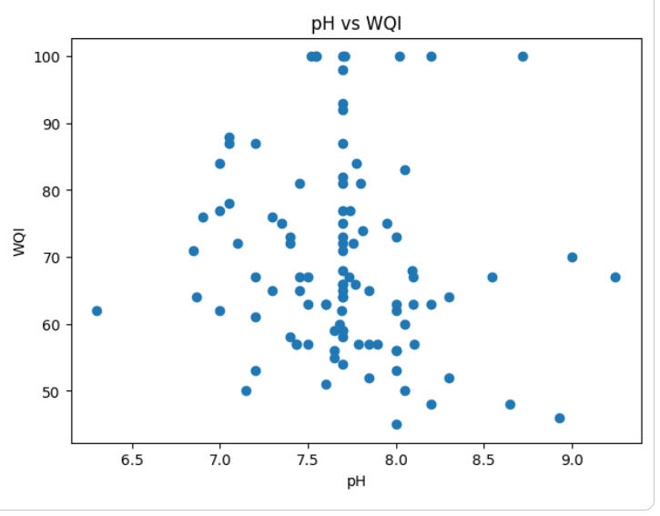
The scatter plot is used to observe the relationship between pH and WQI. The distribution of points helps understand how WQI values vary with pH.
6.6.2 DO vs WQI
Figure 6.14: DO vs WQI
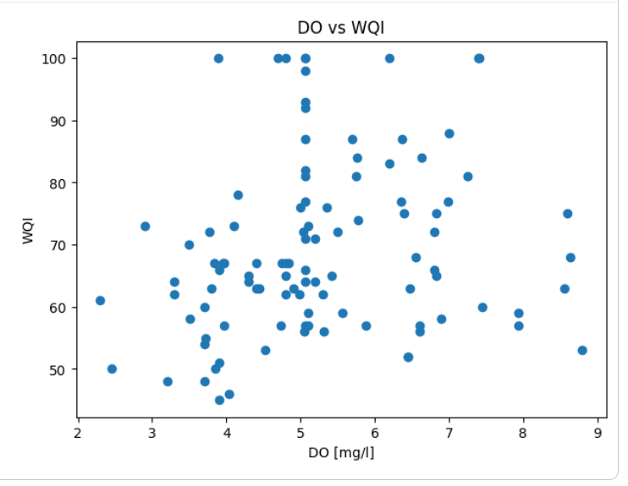
The graph shows the distribution of WQI values with respect to Dissolved Oxygen. It provides a visual representation of the relationship between the two parameters.
6.6.3 TDS vs WQI
Figure 6.15: TDS vs WQI
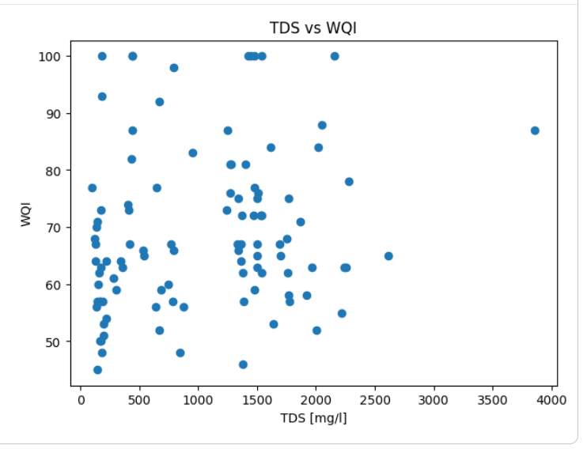
The scatter plot shows the relationship between Total Dissolved Solids and WQI. It helps observe how WQI values are distributed for different TDS values.
6.6.4 Turbidity vs WQI
Figure 6.16: Turbidity vs WQI
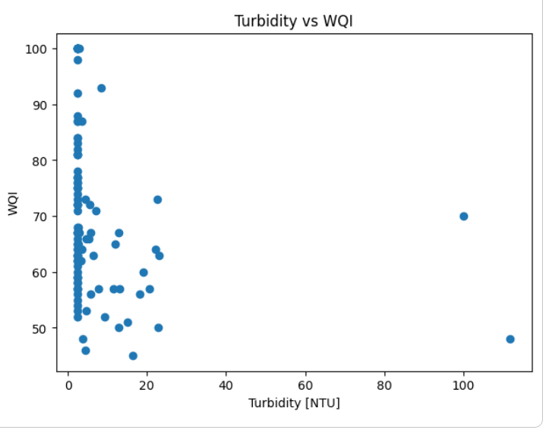
The graph represents the relationship between Turbidity and WQI. The distribution of points helps observe the variation of WQI for different turbidity values.
6.6.5 TDS vs pH
Figure 6.17: TDS vs pH
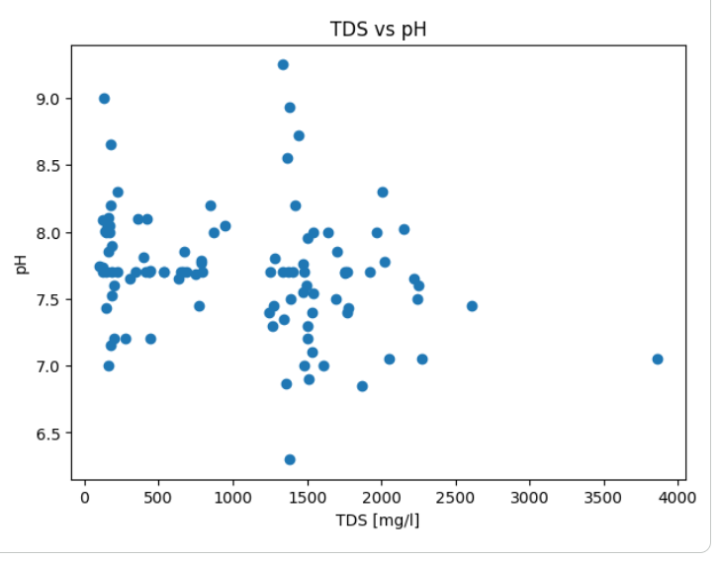
The scatter plot represents the relationship between TDS and pH. TDS represents the amount of dissolved substances in water, while pH represents the acidic or alkaline nature of water. The distribution of data points helps observe the pattern and variation between these two parameters.

6.7 Project Specific Visualization
Apart from the standard graphs, additional visualizations and analyses were performed according to the requirements of the Water Quality Data Analysis System.
6.7.1 Sampling Site Frequency Analysis
The frequency of observations at each sampling site was calculated using the value_counts() function.
This analysis helps understand how the observations are distributed among the sampling locations.
6.7.2 Average WQI by Sampling Site
The average values of pH, DO, TDS, Turbidity, and WQI were calculated for each sampling site using group-based analysis.
The average WQI was then visualized using a bar graph to compare water-quality conditions between locations.
6.7.3 Correlation Analysis
A correlation matrix was calculated for important water-quality parameters, including:
- pH
- DO
- TDS
- Turbidity
- TSS
- BOD
- TN
- TP
- EC
- WQI
The correlation matrix was then visualized using a heatmap.
Figure 6.18: Correlation Heatmap of Water Quality Parameters
The heatmap provides a visual representation of the relationships between the selected numerical water-quality parameters. It helps identify the strength and direction of relationships between the variables.
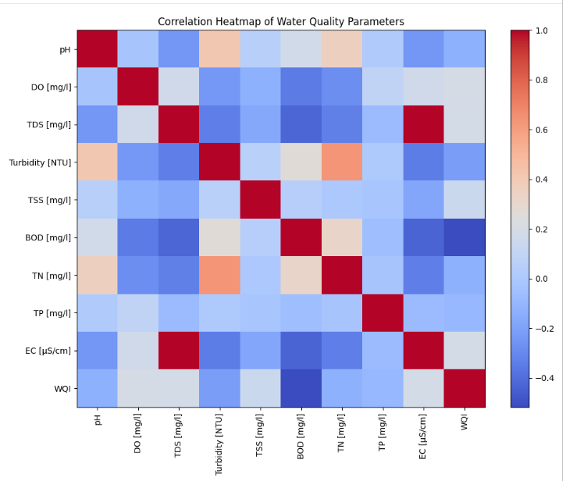
6.7.4 Water Quality Classification Analysis
The Water Quality categories were analyzed using frequency counts. The final implementation identified the different categories and calculated the number of observations in each category.
The WQI statistics were also calculated for each Water Quality category using:
- Count
- Mean
- Minimum
- Maximum
This provides additional information for understanding the WQI distribution within each classification.

6.8 Interpretation of Visualizations
The visualizations generated in the project provide different views of the water-quality dataset.
- Bar graphs were used to compare average WQI across sampling locations and to represent Water Quality classification counts.
- Histograms were used to understand the distribution of pH, DO, TDS, Turbidity, and WQI.
- Box plots were used to understand the spread of the parameters and identify potential outliers.
- Scatter plots were used to examine relationships between pH, DO, TDS, Turbidity, and WQI.
- Correlation heatmap was used to visualize relationships among the selected numerical water-quality parameters.
- Water Quality classification analysis provided an overall view of the number of observations belonging to each category.
Overall, the visualizations helped convert the numerical water-quality dataset into an easily understandable graphical form. They support the analysis of parameter distributions, location-wise variations, relationships between variables, and overall Water Quality classification. The project documentation and Review-2 material also identify these visualization-based analyses as part of the project results.

CHAPTER 7
MODEL EVALUATION / ANALYSIS OF RESULTS
This chapter presents the results obtained from the analysis of the cleaned water-quality dataset. The project does not use a machine-learning prediction model; therefore, the results are evaluated using descriptive statistics, Water Quality classification, location-wise WQI analysis, distribution analysis, and correlation analysis.

7.1 Evaluation Metrics
Since the current implementation is based on descriptive data analysis and visualization, machine-learning evaluation metrics such as accuracy, precision, recall, F1-score, and confusion matrix are not applicable.
Instead, the following measures were used to analyze the dataset:
7.1.1 Descriptive Statistical Measures
The following statistical measures were calculated for important water-quality parameters:
- Mean
- Standard Deviation
- Minimum
- Maximum
- Quartiles
The major parameters considered were:
- pH
- Dissolved Oxygen (DO)
- Total Dissolved Solids (TDS)
- Turbidity
- Water Quality Index (WQI)
These measures help understand the central tendency, spread, and variation of the water-quality parameters.
7.1.2 Water Quality Classification
The number of observations in each Water Quality category was calculated.
Table 7.1 : Water Quality Classification
Water Quality Category | Number of Observations
FAIR | 58
EXCELLENT | 22
GOOD | 19
POOR | 4
Total | 103

The classification provides an overall view of the water-quality conditions represented in the dataset.
7.1.3 Location-wise WQI Analysis
Average WQI was calculated for each of the 12 sampling locations. This measure was used to compare the overall water-quality conditions between different locations.
7.1.4 Correlation Analysis
Correlation analysis was performed to examine relationships between numerical water-quality parameters. The results were represented using a correlation heatmap.

7.2 Experimental Results
The analysis was performed on the cleaned dataset containing 103 observations and 21 attributes.
The major numerical results obtained from the analysis are shown below.
Table 7.2 : Experimental Results / Statistical Summary
Parameter | Mean | Minimum | Maximum
pH | 7.7016 | 6.30 | 9.25
DO (mg/l) | 5.2628 | 2.30 | 8.80
TDS (mg/l) | 1034.4211 | 99.20 | 3861.32
Turbidity (NTU) | 7.0251 | 2.50 | 111.85
WQI | 69.2233 | 45 | 100

The results show that the water-quality parameters have different ranges and levels of variation across the observations.
Water Quality Classification Results
The classification analysis produced the following results:
- FAIR: 58 observations
- EXCELLENT: 22 observations
- GOOD: 19 observations
- POOR: 4 observations
The results indicate that the dataset contains observations belonging to multiple Water Quality categories.
Table 7.3 : WQI Statistics by Classification
Water Quality | Count | Mean WQI | Minimum WQI | Maximum WQI
EXCELLENT | 22 | 91.27 | 81 | 100
FAIR | 58 | 60.79 | 50 | 70
GOOD | 19 | 74.16 | 71 | 78
POOR | 4 | 46.75 | 45 | 48

These results provide a numerical summary of WQI values within each Water Quality category.

7.3 Result Interpretation
The results obtained from the analysis and visualization provide the following observations:
1. Water Quality Parameters
The analyzed parameters show variation across the dataset. Parameters such as pH, DO, TDS, and Turbidity h1ave different ranges, indicating differences among the collected water samples.
2. pH Analysis
The average pH value is 7.7016, with values ranging from 6.30 to 9.25. The pH histogram helps visualize the distribution of pH observations.
3. Dissolved Oxygen Analysis
The average DO value is 5.2628 mg/l, with values ranging from 2.30 to 8.80 mg/l. The distribution of DO values was examined using statistical measures and visualization.
4. TDS Analysis
The average TDS value is 1034.4211 mg/l, with values ranging from 99.20 to 3861.32 mg/l. The TDS visualizations help understand the variation in dissolved solids among the observations.
5. Turbidity Analysis
The average turbidity value is 7.0251 NTU, with values ranging from 2.50 to 111.85 NTU. The histogram and box plot help examine its distribution and potential unusual observations.
6. WQI Analysis
The average WQI is 69.2233, with values ranging from 45 to 100. WQI was also analyzed according to Water Quality classification.
7. Location-wise Analysis
Average WQI was calculated for each sampling location. The corresponding bar graph provides a visual comparison of water-quality conditions across the 12 sampling sites.
8. Relationship Analysis
Scatter plots were used to visually examine relationships such as:
- pH vs WQI
- DO vs WQI
- TDS vs WQI
- Turbidity vs WQI
- TDS vs pH
The correlation heatmap provides an additional view of relationships between numerical water-quality parameters.

7.4 Discussion
The Water Quality Data Analysis System successfully performed data preparation, exploratory analysis, statistical analysis, and visualization on the selected water-quality dataset.
The preprocessing stage handled 52 missing values using median imputation, and the dataset contained 0 duplicate records. Potential outliers were identified using box plots and the IQR method and were retained because they may represent genuine water-quality variations.
The analysis showed that water-quality parameters vary across the observations and sampling locations. Location-wise WQI analysis helped compare water-quality conditions between sites, while Water Quality classification provided an overall view of the analyzed samples. The project also used histograms, box plots, scatter plots, bar graphs, and correlation analysis to represent the results graphically.
The current implementation is focused on understanding and analyzing the existing dataset rather than predicting future water-quality conditions. Therefore, no machine-learning evaluation metrics were used.
The analysis provides a foundation for future development of a predictive water-quality system using machine-learning techniques.

CHAPTER 8
OUTPUT SCREENSHOTS
This chapter presents the important outputs obtained during the implementation of the Water Quality Data Analysis System. The screenshots demonstrate the dataset loading, preprocessing results, visualizations, and final analysis outputs obtained using Python in Google Colab.
8.1 Input / Dataset Screenshots
The dataset was loaded into Google Colab using Python and Pandas. The dataset contains 103 observations and 21 attributes related to water quality.
Figure 8.1: Dataset Loaded in Google Colab
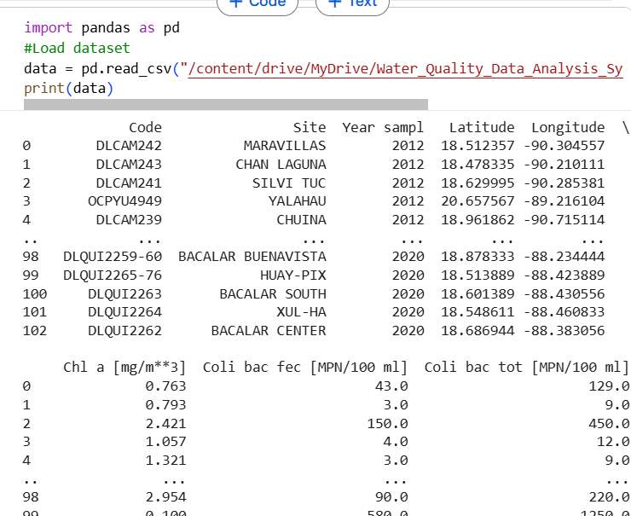

The screenshot should show the dataset being successfully loaded using Pandas.
Figure 8.2: First Few Records of the Dataset
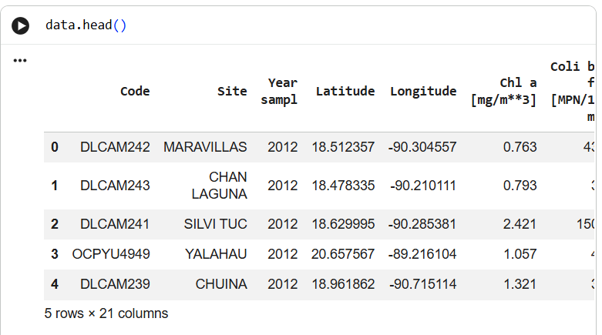
The head() function was used to display the first few records of the dataset and verify that the data was loaded correctly.
Figure 8.3: Dataset Shape and Structure
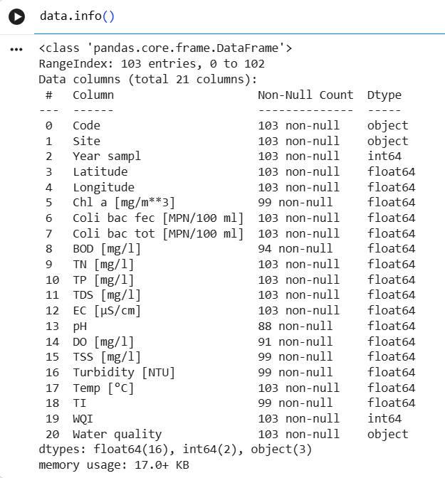
The dataset structure was examined to understand the number of observations, attributes, and data types.
The dataset contains:
- 103 observations
- 21 attributes
- Numerical and categorical attributes
- Sampling-site information
- Water-quality parameters
- WQI and Water Quality classification

8.2 Preprocessing Outputs
The preprocessing stage was performed to identify and handle missing values, duplicate records, potential outliers, and data types.
Figure 8.4: Missing Value Analysis
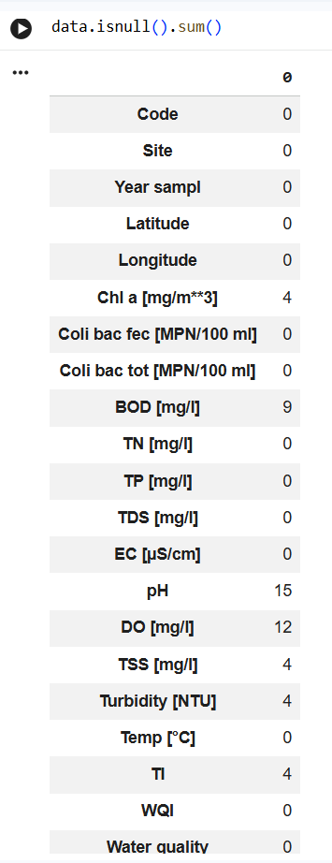
The initial dataset contained 52 missing values distributed among seven attributes.
The missing values were handled using median imputation.
Figure 8.5: Missing Values After Imputation
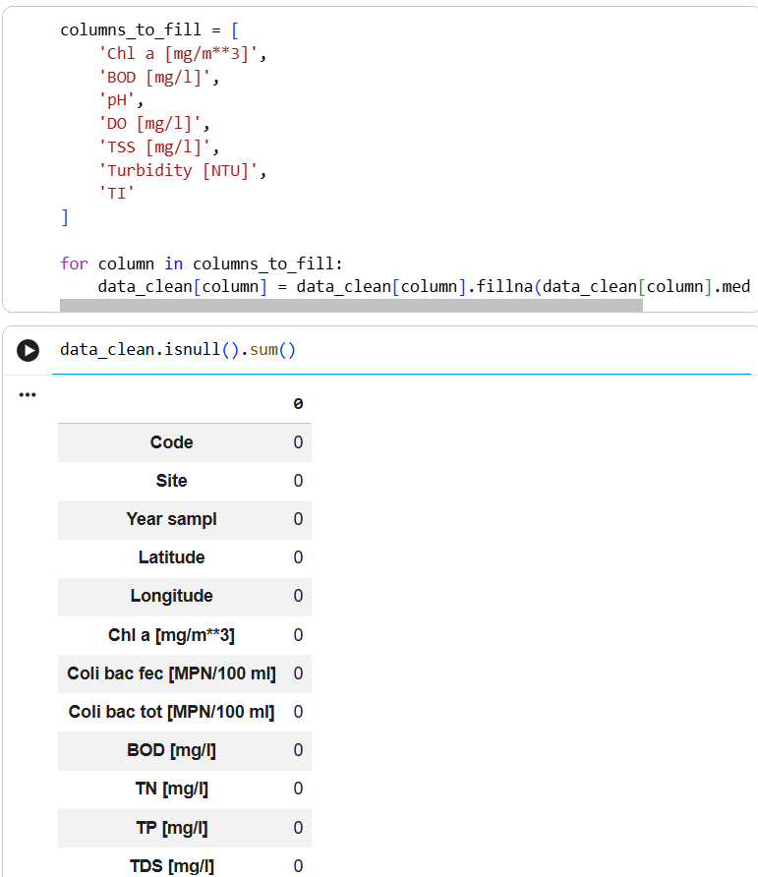

After median imputation, the missing-value check showed that the required attributes contained no remaining missing values.
Figure 8.6: Duplicate Record Check
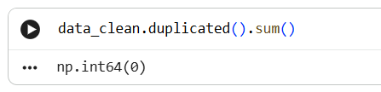
The duplicate-record check resulted in 0 duplicate records. Therefore, no records were removed because of duplication.
Figure 8.7: Data Types Verification
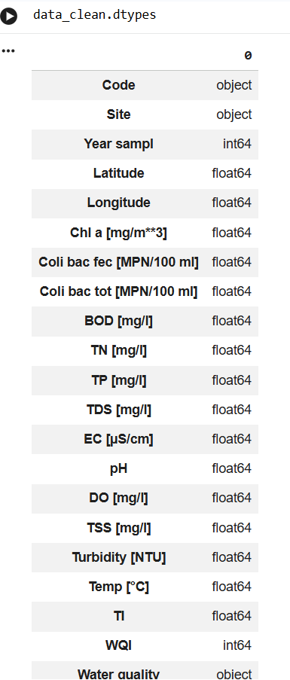

The data types of the attributes were checked after preprocessing.
Numerical attributes were retained in numerical form, while categorical attributes such as Site and Water quality were identified. Encoding was not required for the current descriptive analysis.
Figure 8.8: Outlier Detection Output
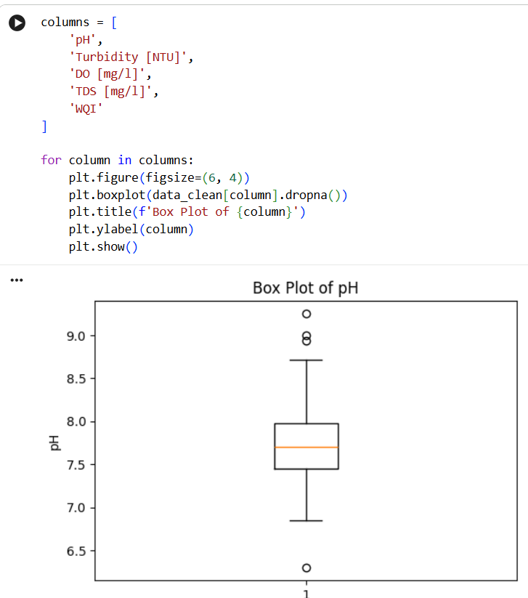
Potential outliers were detected using the Box Plot and Interquartile Range (IQR) method.
The detected values were examined and retained because they may represent genuine variations in water-quality conditions.
8.3 Visualization Outputs
The visualization outputs generated during the implementation are presented in this section. These screenshots provide evidence of the graphs produced using Python libraries such as Matplotlib and Seaborn. The visualizations help in understanding the distribution of water-quality parameters, comparing water quality across sampling locations, and identifying relationships between important parameters.
8.3.1 Average WQI by Sampling Site
Figure 8.9: Average WQI by Sampling Site
A bar chart was generated to compare the average Water Quality Index (WQI) across the different sampling locations. The visualization helps identify variations in water quality between sampling sites.
8.3.2 pH Distribution Histogram
Figure 8.10: Distribution of pH Values
A histogram was generated to show the distribution of pH values in the cleaned dataset. It helps identify the common range of pH values and observe the variation in the dataset.
8.3.3 Box Plot for Outlier Detection
Figure 8.11: Box Plot for Water-Quality Parameters
Box plots were used to identify potential outliers in important parameters such as pH, Turbidity, DO, TDS, and WQI. The visualization supports the IQR-based outlier analysis performed during preprocessing.
8.3.4 TDS vs pH Scatter Plot
Figure 8.12: TDS vs pH Scatter Plot
A scatter plot was generated to examine the relationship between Total Dissolved Solids (TDS) and pH. The distribution of data points helps in understanding the variation between these two water-quality parameters.
8.3.5 Correlation Heatmap
Figure 8.13: Correlation Heatmap of Water-Quality Parameters
A correlation heatmap was generated to examine the relationships among numerical water-quality parameters. It provides a visual representation of the correlation between different variables and helps identify parameters that show stronger or weaker relationships.

8.4 Prediction / Analysis Outputs
Since the current implementation does not use a machine-learning prediction model, prediction screenshots such as predicted values, confusion matrices, accuracy, or classification reports are not applicable.
Instead, the final analysis outputs are presented through statistical and classification results.
Figure 8.14: Descriptive Statistical Analysis
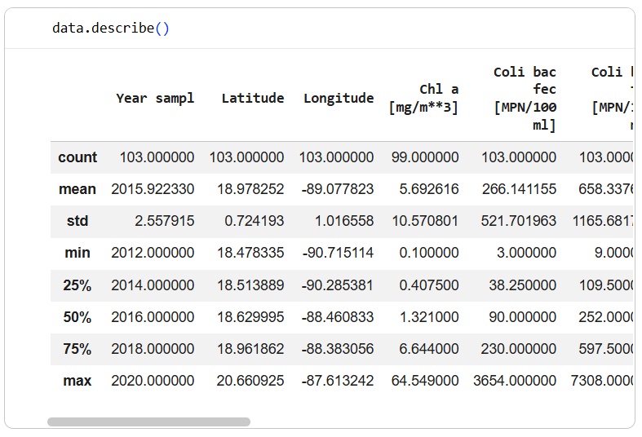
The statistical analysis provides measures such as:
- Mean
- Standard deviation
- Minimum
- Maximum
- Quartiles
for the important water-quality parameters.

8.5 Summary of Output Screenshots
The implementation produced outputs at different stages of the project:
- Dataset Loading – confirms successful import of the water-quality dataset.
- Dataset Exploration – displays the structure and initial records.
- Missing Value Handling – confirms successful median imputation.
- Duplicate Checking – confirms that no duplicate records were present.
- Outlier Detection – identifies potential unusual observations using Box Plot and IQR.
- Statistical Analysis – provides numerical summaries of important parameters.
- Location-wise Analysis – compares average WQI across sampling sites.
- Classification Analysis – presents the distribution of Water Quality categories.
- Visualization – includes histograms, box plots, bar graphs, scatter plots, and correlation heatmap.
- Final Analysis – provides an overall understanding of the water-quality dataset.
The project therefore produces analysis-based outputs rather than prediction outputs, consistent with the current implementation. The project material describes the analysis as focusing on statistical analysis, location-wise WQI, classification, pH distribution, and parameter relationships.

CHAPTER 9
CONCLUSION AND FUTURE ENHANCEMENTS
9.1 Conclusion
The Water Quality Data Analysis System was successfully developed to analyze and understand water-quality observations using Python and data-analysis techniques.
The dataset was collected from PANGAEA and contained 103 observations with 21 attributes from different sampling locations. The dataset was first explored to understand its structure, attributes, data types, and statistical properties.
Data preprocessing was performed to improve the quality of the dataset. A total of 52 missing values were identified across seven attributes and were handled using median imputation. Duplicate records were checked, and no duplicate records were found. Potential outliers were identified using Box Plot and the IQR method and were retained after examination.
Exploratory Data Analysis was then performed on important water-quality parameters such as pH, Turbidity, Dissolved Oxygen (DO), TDS, and WQI. Statistical analysis and visualizations were used to understand the distribution and variation of these parameters.
The project also compared average WQI across sampling locations and analyzed the available Water Quality classifications. Histograms, box plots, scatter plots, bar charts, and correlation analysis helped identify patterns and relationships within the dataset.
Overall, the project successfully demonstrates how data analytics techniques can be used to clean, analyze, visualize, and interpret water-quality data. The analysis provides a clear understanding of variations in water quality across sampling locations and establishes a foundation for further development.

9.2 Limitations
The current implementation has the following limitations:
- The analysis is based on a limited dataset of 103 observations and 12 sampling locations.
- The project focuses mainly on descriptive analysis, statistical analysis, and visualization and does not currently implement a machine-learning prediction model.
- The dataset represents specific sampling locations and therefore may not represent water-quality conditions in other geographical regions.
- The analysis uses the parameters available in the selected dataset. Additional environmental and water-quality parameters could provide more detailed analysis.
- The current implementation is performed using a Python-based analysis environment and does not provide a dedicated real-time monitoring interface.
- The project does not currently perform real-time water-quality prediction or continuous monitoring.

9.3 Future Enhancements
The project can be enhanced in the following ways:
1.Machine Learning Prediction
Develop machine-learning models to predict future water-quality conditions using historical water-quality parameters.
2.Real-Time Monitoring
Integrate real-time data from water-quality sensors to continuously monitor parameters such as pH, TDS, turbidity, and dissolved oxygen.
3.Interactive Dashboard
Develop an interactive dashboard to display water-quality parameters, WQI, sampling locations, and analysis results.
4.More Sampling Locations
Include data from additional geographical locations to improve the coverage of the analysis.
5.Larger Datasets
Use larger and more recent datasets to improve the reliability and scope of the analysis.
6.Advanced Visualization
Add interactive charts, geographical maps, and location-based visualizations for easier interpretation.
7.Water Quality Forecasting
Use historical observations to forecast future changes in water-quality conditions.
8.Automated Alerts
Develop an alert mechanism that can notify users when important water-quality parameters cross specified limits.
These enhancements can extend the current descriptive analysis system into a more comprehensive water-quality monitoring and prediction system. The future-enhancement directions are also consistent with the project material, which identifies machine-learning prediction, historical-parameter analysis, additional locations/datasets, and an interactive dashboard as possible next steps.

REFERENCES
1. PANGAEA – Data Publisher for Earth & Environmental Science, Water-quality observations from the Yucatán Peninsula, Mexico, Dataset used for the Water Quality Data Analysis System.
2. Python Software Foundation, Python Documentation, Python Programming Language.
3. Pandas Documentation, Pandas: Python Data Analysis Library.
4. NumPy Documentation, NumPy: The Fundamental Package for Scientific Computing with Python.
5. Matplotlib Documentation, Matplotlib: Visualization with Python.
6. Seaborn Documentation, Seaborn: Statistical Data Visualization.
7. Google Colaboratory, Google Colab Documentation, Google.
8. Aditya University, Data Analysis Essentials (DAE) – Cornerstone Project Guidelines and Course Material.

APPENDIX – SOURCE CODE
The complete source code used for the implementation of the Water Quality Data Analysis System is provided in this appendix. The project was implemented using Python in Google Colab. The source code includes dataset loading, dataset exploration, preprocessing, missing-value handling, duplicate checking, outlier detection, exploratory data analysis, statistical analysis, water-quality classification, visualization, and correlation analysis.
Source Code
import pandas as pd
import numpy as np
import matplotlib.pyplot as plt
import seaborn as sns

# Load dataset
data = pd.read_csv(
"/content/drive/MyDrive/Water_Quality_Data_Analysis_System/Conagua_2012-202.csv"
)

print(data)

# Initial dataset understanding
data.head()
data.shape
data.info()
data.describe()

# Check missing values
data.isnull().sum()

# Create cleaned dataset
data_clean = data.copy()

# Columns with missing values
columns_to_fill = [
'Chl a [mg/m**3]',
'BOD [mg/l]',
'pH',
'DO [mg/l]',
'TSS [mg/l]',
'Turbidity [NTU]',
'TI'
]

# Median imputation
for column in columns_to_fill:
data_clean[column] = data_clean[column].fillna(
data_clean[column].median()
)

# Check missing values after preprocessing
data_clean.isnull().sum()

# Check duplicate records
data_clean.duplicated().sum()
data_clean.shape

# Check data types
data_clean.dtypes

# Outlier detection using Box Plot
columns = [
'pH',
'Turbidity [NTU]',
'DO [mg/l]',
'TDS [mg/l]',
'WQI'
]

for column in columns:
plt.figure(figsize=(6, 4))
plt.boxplot(data_clean[column].dropna())
plt.title(f'Box Plot of {column}')
plt.ylabel(column)
plt.show()

# Outlier detection using IQR
for column in columns:
Q1 = data_clean[column].quantile(0.25)
Q3 = data_clean[column].quantile(0.75)
IQR = Q3 - Q1

lower_bound = Q1 - 1.5 * IQR
upper_bound = Q3 + 1.5 * IQR

outliers = data_clean[
(data_clean[column] < lower_bound) |
(data_clean[column] > upper_bound)
]

print(f"{column}: {len(outliers)} outliers")

# Descriptive statistical analysis
data_clean[
[
'pH',
'Turbidity [NTU]',
'DO [mg/l]',
'TDS [mg/l]',
'WQI'
]
].describe()

# Average WQI by sampling site
site_wqi = data_clean.groupby('Site')['WQI'].mean()

plt.figure(figsize=(10, 6))
site_wqi.plot(kind='bar')

plt.title('Average WQI by Sampling Site')
plt.xlabel('Sampling Site')
plt.ylabel('Average WQI')
plt.xticks(rotation=45)
plt.show()

# Water Quality classification
data_clean['Water quality'].value_counts()

# Histograms
parameters = [
'pH',
'DO [mg/l]',
'TDS [mg/l]',
'Turbidity [NTU]',
'WQI'
]

for column in parameters:
plt.figure(figsize=(8, 5))
plt.hist(data_clean[column], bins=10)

plt.title(f'Distribution of {column}')
plt.xlabel(column)
plt.ylabel('Frequency')

plt.show()

# Scatter plot: TDS vs pH
plt.figure(figsize=(8, 5))

plt.scatter(
data_clean['TDS [mg/l]'],
data_clean['pH']
)

plt.title('TDS vs pH')
plt.xlabel('TDS [mg/l]')
plt.ylabel('pH')

plt.show()

# Scatter plot analysis
scatter_pairs = [
('pH', 'WQI'),
('DO [mg/l]', 'WQI'),
('TDS [mg/l]', 'WQI'),
('Turbidity [NTU]', 'WQI'),
('TDS [mg/l]', 'pH')
]

for x, y in scatter_pairs:
plt.figure(figsize=(7, 5))

plt.scatter(
data_clean[x],
data_clean[y]
)

plt.xlabel(x)
plt.ylabel(y)
plt.title(f'{x} vs {y}')

plt.show()

# Correlation analysis
correlation = data_clean.corr(numeric_only=True)

print(correlation)

# Correlation heatmap
plt.figure(figsize=(12, 8))

sns.heatmap(
correlation,
annot=True
)

plt.title('Correlation Heatmap of Water-Quality Parameters')
plt.show()

# WQI statistics by water-quality classification
wqi_statistics = data_clean.groupby(
'Water quality'
)['WQI'].agg(
['count', 'mean', 'min', 'max']
)

print(wqi_statistics)

# Final dataset checks
print(data_clean.shape)
print(data_clean.isnull().sum())
print(data_clean.duplicated().sum())

